To Creat Email Subscribe list by the Mail Chimp

Log in with Mailchimp

Click Create list and generate the code to link with the wordpress.

Wordpress Jet pack have inbuilt option to connect with the Mailchimp

Select Custom Option in slide bar add widgets option and connect with the mailchimp

It will ask for some Java scripts its can be generated with the MailChimp account.

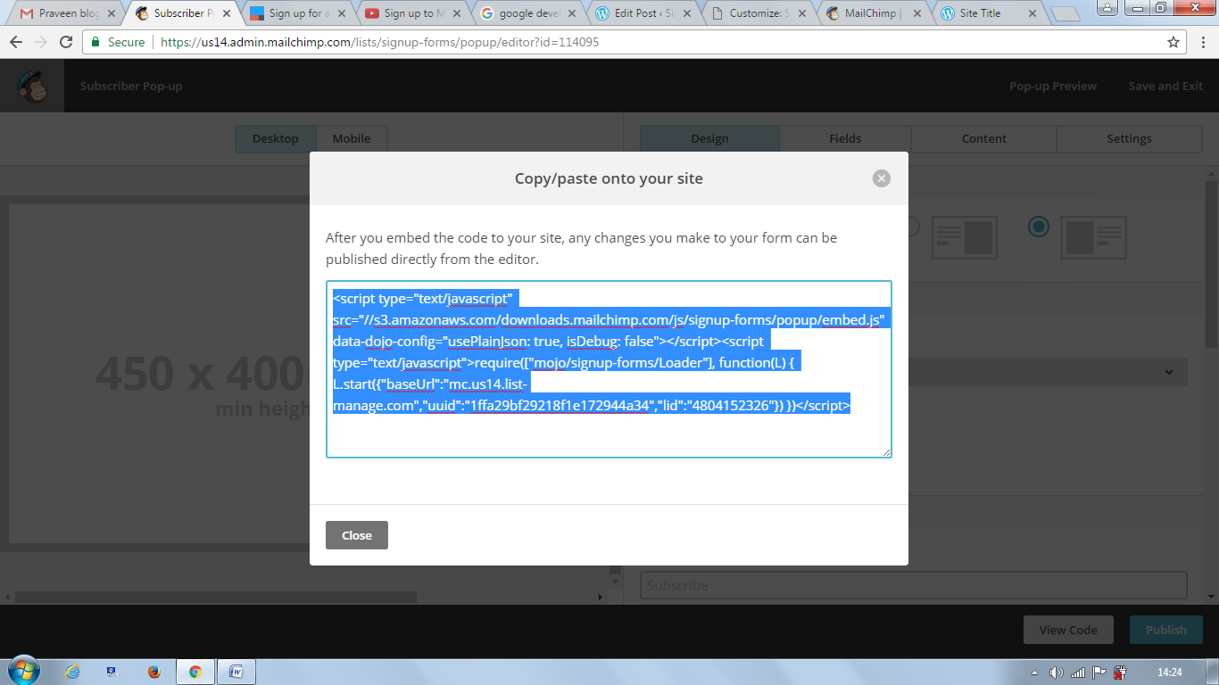

These are the auto generated Code.

Just Copy the code and paste at the wordpress widget box.

Email Subscriber Pop up will appear.

We can get the email to subscribe pop up our blog .

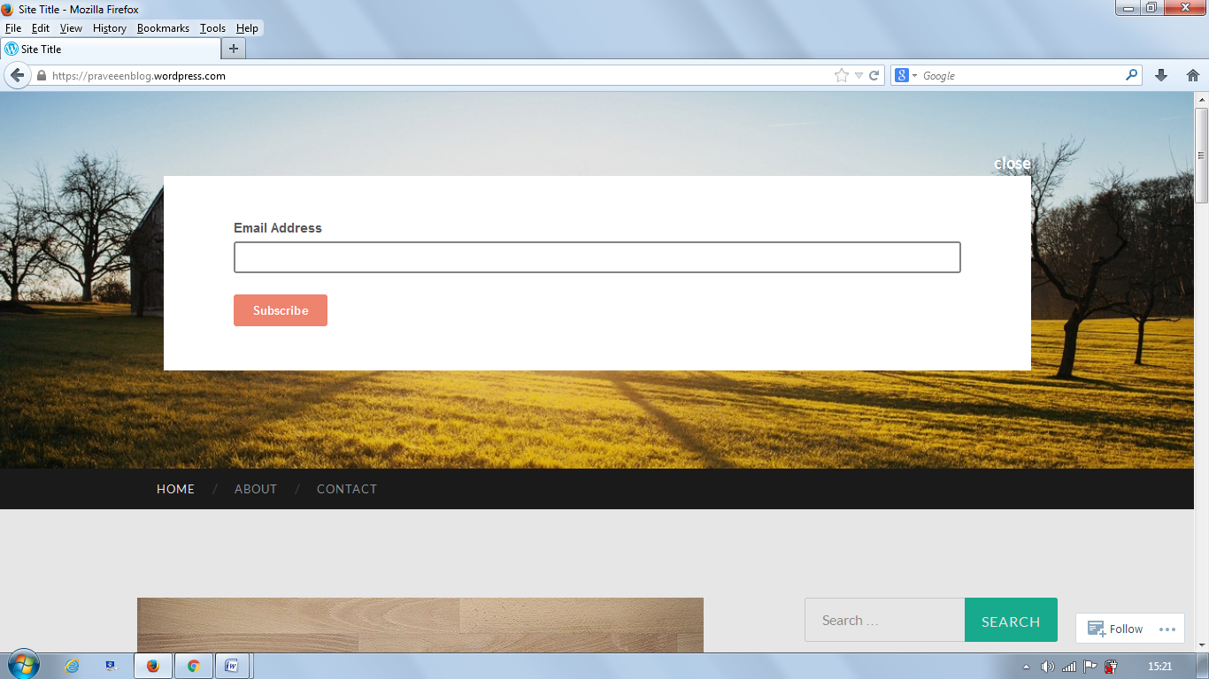

Mailchimp will send activation mail to the Subscriber.

We can get our subscriber details in a Mailchimp account.

We can send the news letters with help of Mailchimp and RSS feeds.

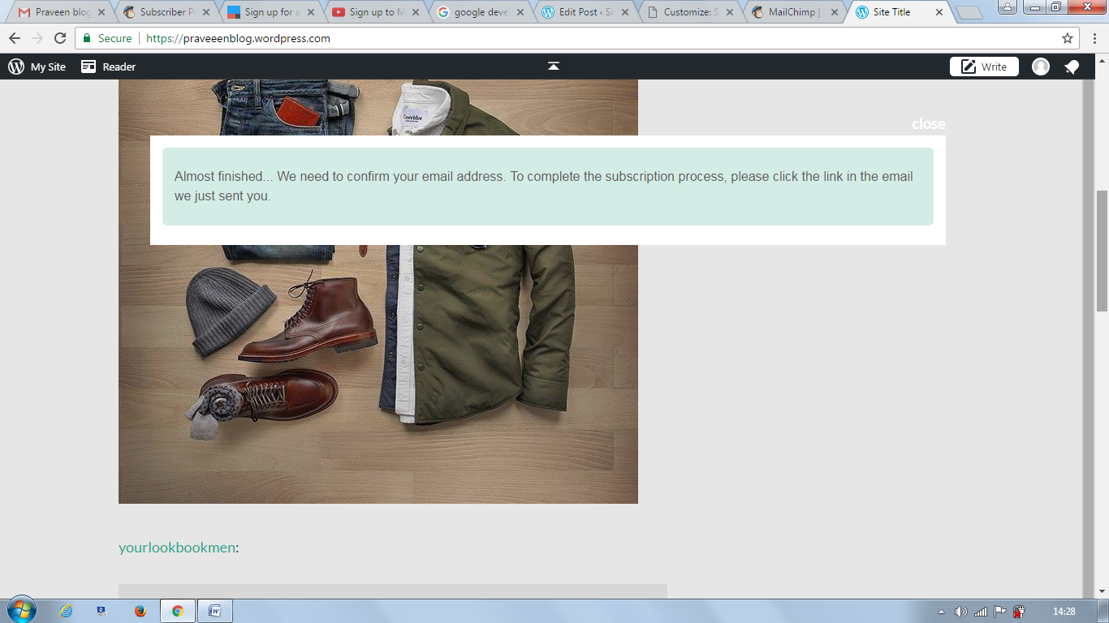

Activation Mail to the Subscriber.

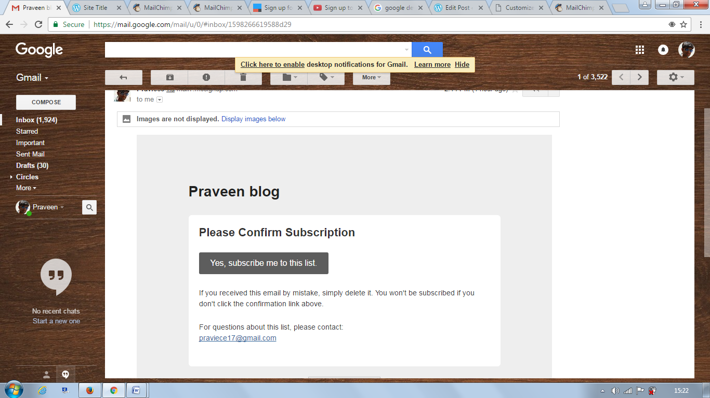

Subscriber Details in Mailchimp Account.

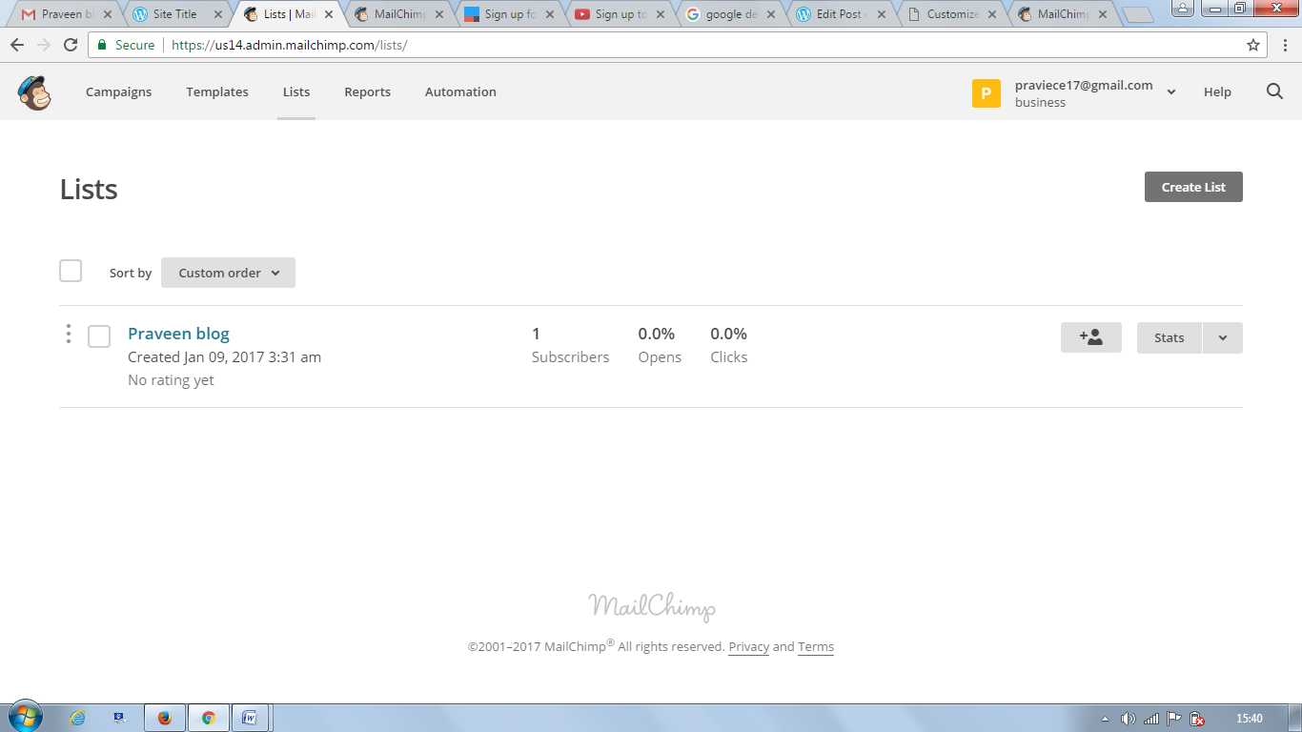

We can also make a auto twitter and Facebook post vai Mailchimp account.

